Linus Learner

Crochet Borders for Fleece Blankets

Base Row – Single Crochet
The base row creates a hem on the blanket, and provides the foundation for the second row. As you crochet, tuck the edge of the blanket down so as to form a hem. This prevents the fleece from fraying.

Look for the silk tag – this will be on the wrong side of the fleece. Hold the right side facing you as you work. (Tip: start near, but not in, a corner.)

Your choice of yarn will dictate which base row you will use.

- Base Row #1 (1 single crochet, chain 1) -- Use this with 4-ply worsted weight (Caron Simply Soft, Big Twist, Vanna’s Choice, Red Heart With Love or Super Saver, etc.)

Insert crochet hook through one of the scored holes and pull loop through. Chain 1. In next hole, do 1 single crochet, chain 1. Continue around fleece. When you reach the corner, do 3 single crochets in the same hole, and chain 1. (Note, for the child’s safety, the corners must be flat, not puckered or curled. You may need to chain 1 in between one or more of the 3 single crochets for this to happen.) When you reach the start, join with a slip stitch.

- Base Row #2 (2 single crochet, no chain) -- Use this with 3-ply soft, baby yarns. (Bernat Softee Baby, Bernat Sport, Lion Brand Baby, Anne Geddes Baby, etc.)

Insert crochet hook through one of the scored holes and pull loop through. Chain 1, single crochet in same hole. In next hole, do 2 single crochets (note there is no chain stitch between).

Continue around fleece, placing 2 single crochets in each hole. When you reach the corner, do 3 single crochets in the same hole. (Note, for the child’s safety, the corners must be flat, not puckered or curled. You may need to chain 1 in between one or more of the 3 single crochets for this to happen.) When you reach the start, join with a slip stitch.
Second Row
For beginners, we recommend either

- Single crochet in each stitch. At the corners, do 3 single crochets in the center stitch of the group of 3 single crochets in the base row.

- Half double crochet in each stitch. At the corners, do 3 half double crochets in the center stitch of the group of 3 single crochets in the base row.

Barber Pole Border (2 color)
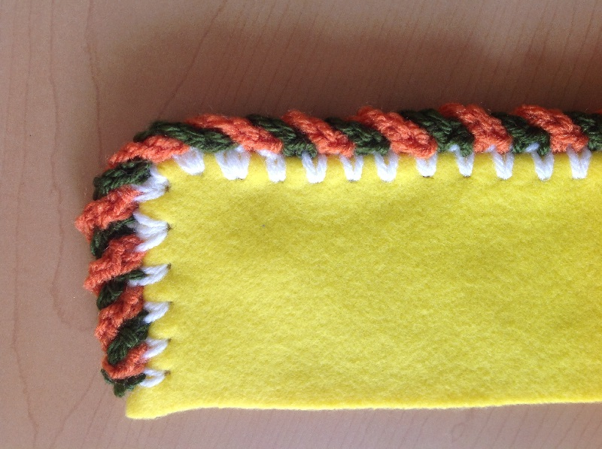
Crochet your base row with color A, but do not fasten off.

Row 2 – begin with single crochet in joining space, chain 4, skip 3 single crochets. Single crochet in next single crochet, pull yarn to front, and drop it. Begin color B with single crochet in 2nd single crochet from beginning single crochet, and chain 4. Skipping 1st single crochet, put single crochet in next single crochet and pull yarn to the front and drop yarn.

Always keep yarn in front of fleece.

Pick up color A (rotate color A over color B), chain 4, skip 1 single crochet and single crochet in next single crochet. Pull yarn to the front and drop it. Pick up color B and repeat pattern to corner. Use 5 chains times 2 going into each corner single crochet. This will keep the corners flat.

3rd Row Chain Stitch Border

Crochet your base row.
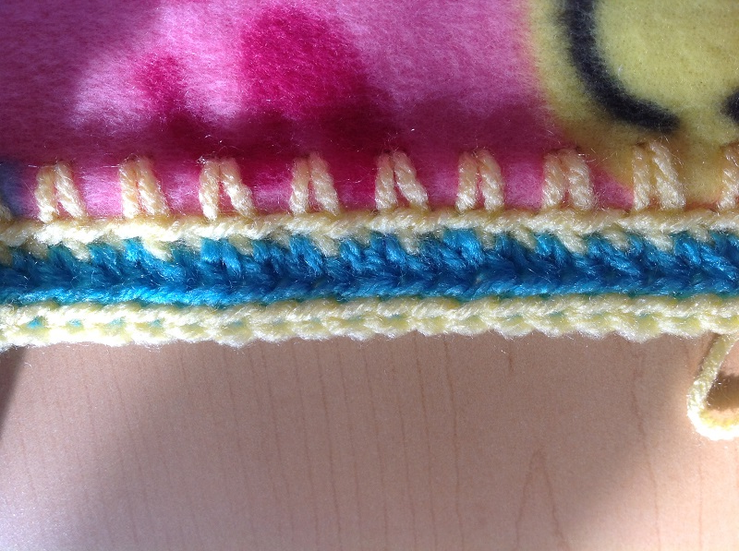

For the second row, single crochet OR half double crochets (your choice) in back loop of each stitch of the base row. In each corner, place 3 or 4 single crochet OR half double crochets (your choice) stitches in the center stitch of the group of 3 in the base row. (However many stitches are needed to have the corners lay flat.)

Third row, slip stitch in back loop of each half double crochet around. (No additional stitches in the corners needed for this row.)

Picot Border
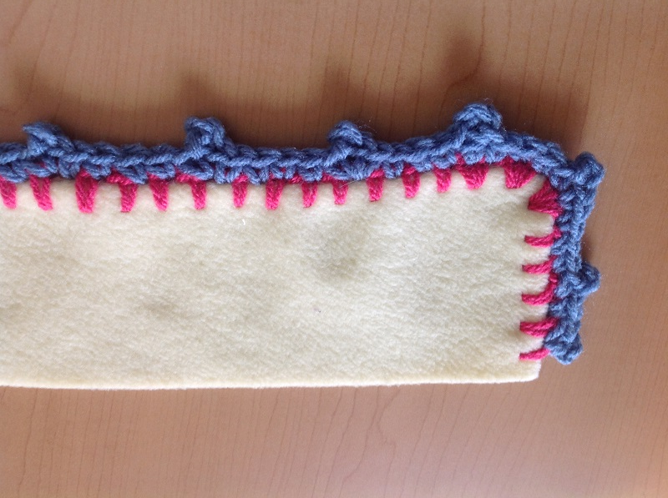

Crochet your base row.

For the second row, make 5 single crochets, chain 3, slip stitch in your first chain. (This makes the picot “bump.”) Then single crochet in the same stitch. Continue this pattern around. (Note: Ideally, at the corners, the picot “bump” should be directly on the corner itself. You may need to adjust the count of the single crochets in order to do this.)

Hearts Border
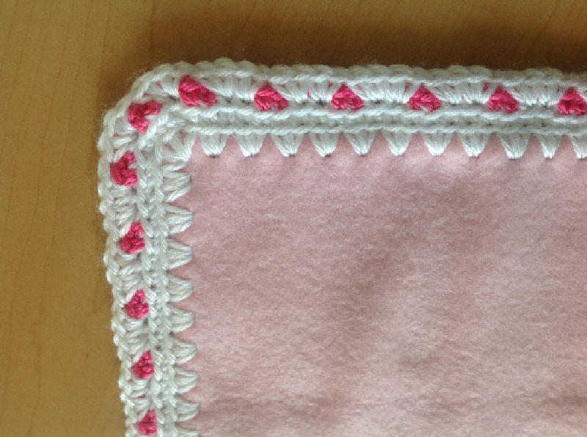

Crochet your base row.
(Note if you are using one single crochet, chain one for your base row, you will need to do a second row of all single crochet to create the correct foundation.)

2nd row: make 2 single crochets, chain 2, skip two stitches, and repeat around. (Add two or 3 extra stitches to adjust to fit corners).

3rd row: make 2 single crochets in each of the two skipped stitches in row 1.

Crab Stitch (Reverse Single Crochet) Border

This is worked the same as you would a single
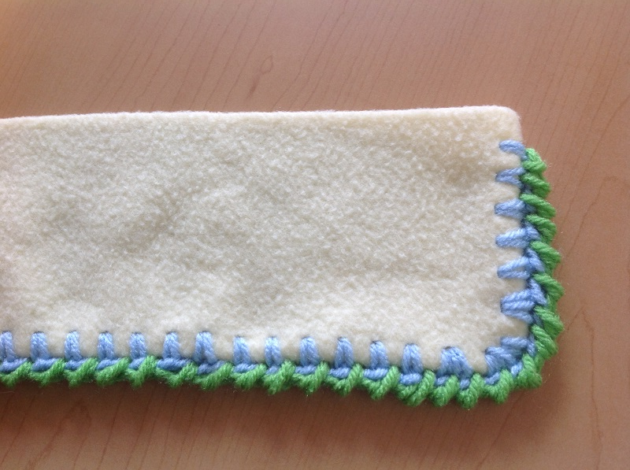
crochet, except backwards. Instead of working
from right to left, you work from left to right.

To begin, insert the hook from front to back in a
stitch of your base row, yarn over and pull through.
Yarn over again, and pull through both loops,
completing the reverse single crochet. Repeat
around. Join with a slip stitch at the beginning
of the row.

Sideways Shell Stitch (a/k/a Half-Shell)

Crochet your base row.

2nd row – *in the same stitch, make slip stitch, chain 3, 3 double crochets. Skip three stitches.* Then, repeat from * to * to end. In the corners, make the shells closer together (skip fewer stitches).
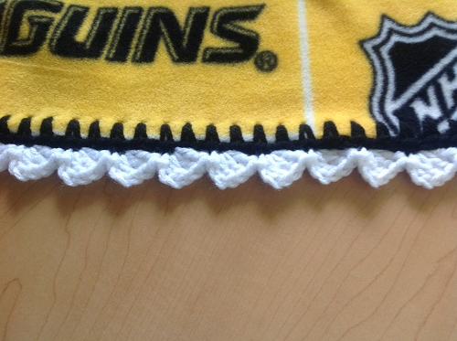

Note – depending on the yarn you use, skipping three stitches can result in a stretched out looking border. You may opt to skip two stitches. Or, alternate skipping three and two.

Variation: *in the same stitch, slip stitch, chain 2, 2 double crochets, skip 2.* This makes a smaller, closer fitting half shell.

Little Loops
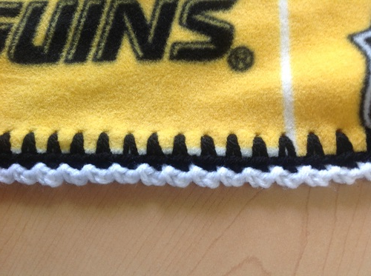

Crochet your base row.

2nd row -- *slip stitch, chain 2, skip 1*.
Repeat all around. Do not skip stitches
in the corners.

