C r o c h e t e d Woo l - E a t e r B l a n k e t
© 2007 Sarah London. All rights reserved. No part of this publication may be reproduced, transmitted, transcribed, scanned,
stored mechanically or electronically, or translated into any language without prior permission of Sarah London.

8 ply yarn
4 mm crochet hook

Ch 6, join with a slip stitch to form a ring.
1st round: * ch 5, work 4 dtr (wrap yarn around hook twice) into the ring,
ensure to leave the last remaining loop of each stitch on the hook as shown
in the photo below,

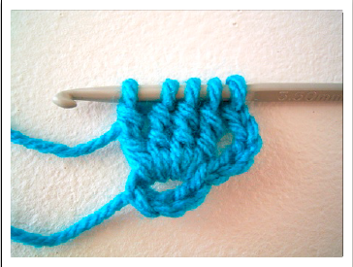

now, yarn over and pull the yarn through all 5 loops on the hook.
{1 cluny group made}.
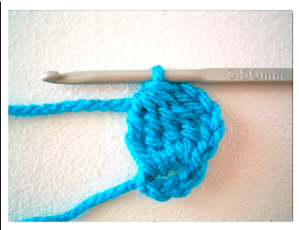
ch 5, slip stitch into the ring.
Rep from * 3 more times.
{4 cluny groups made}.

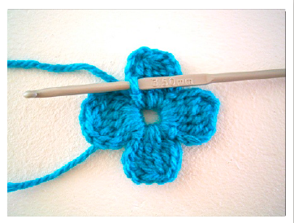
Round 2: * ch 2, work 12 dtr into the top of the cluny group, ch 2, slip stitch
i n t o t h e s l i p s t i t c h o f t h e p r e v i o u s r o u n d .
Rep from * 3 times.
Fasten off.
{4 corners made}.
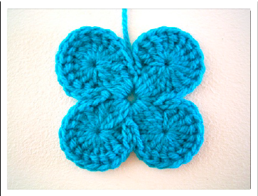

Round 3: Join new colour in between any 4th and 5th dtr of the previous
round.
Ch 5, working from the back around to the front of the stem of the dtr of the
previous round, and out at the back, make a cluny group over the next 4 dtr,
ch 5, slip stitch in between the 8th and 9th dtr of the previous round, ch 5,
work a cluny group of 8 dtr over the next 8 dtr of the previous round, ch 5,
slip stitch between the 4th and 5th dtr of the next 12 dtr corner group.
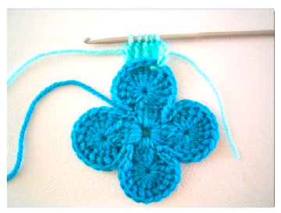

Continue working round in this manner, finishing with a slip stitch into
where the contrast yarn was joined at the beginning of the round.

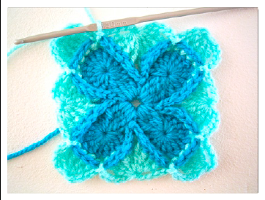

Round 4: Ch 2, 12 dtr into the top of the 4 cluny group, ch 2, slip stitch into
slip stitch of the previous round, ch 2, 8 dtr into the top of the 8 cluny
group, ch 2, slip stitch into slip stitch of the previous round.
Continue working round in this manner, finishing with a slip stitch.
Fasten off.

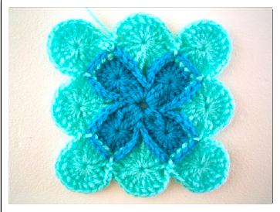

C o n t i n u e i n p a t t e r n f o r m a t i o n .

Please take a look at our flickr group, you’ll find amazing inspiration and gorgeous colour combinations.
http://www.flickr.com/groups/795003@N25/pool/
.