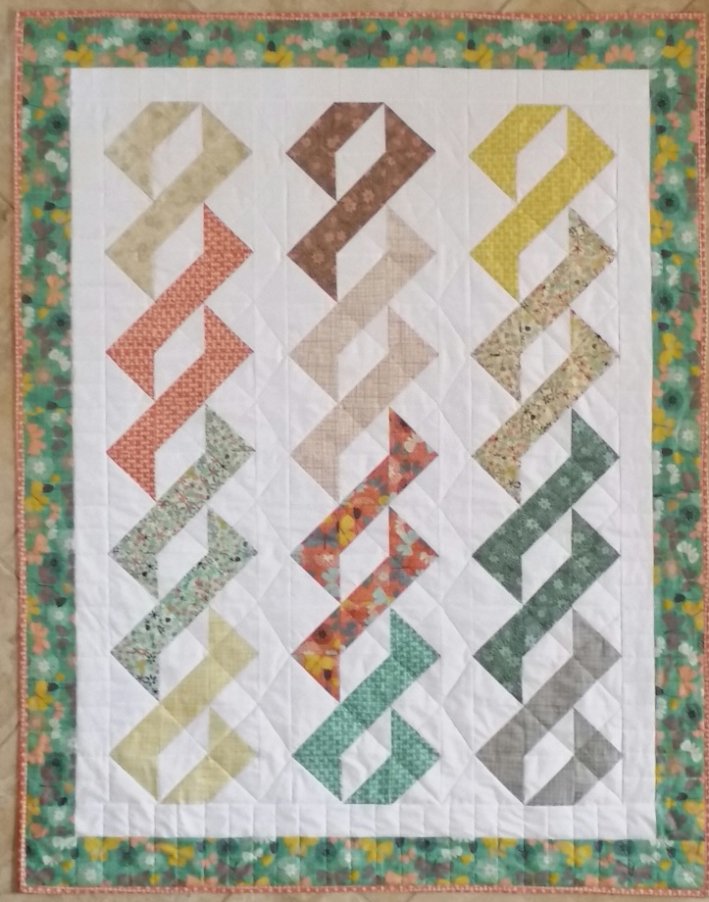
IT’S A WRAP
Size Approximately: 41” x 52”
MATERIALS NEEDED:
- TWELVE (12) CONTRASTING FABRICS: One “fat eighth” or twelve (12) 8” x 12” rectangles of each of twelve (12) different contrasting fabrics. Note: A “fat eighth” is a 9” x 21” piece of fabric.
- WHITE BACKGROUND FABRIC: 1 ¼ yards
- 3” FINISHED (3 ½” unfinished) HALF SQUARE TRIANGLE (HST) PAPERS:
  - 12 papers of eight (8) HSTs
  - Six (6) papers of four (4) HSTs
- OUTER BORDERS (vertical borders will be pieced): About 1/2 yard or five (5) 3 ½” x WOF
- BINDING: About ½ yard or five (5) 2 ½” x WOF strips
- BACKING AND BATTING: Cut to size
- Note: You need a total of 126 HSTs. You will make 120 HSTs using the papers. You will make six (6) HSTs (one HST from each of fabrics 1,4,5,8,9 and 12) using a traditional method.

ADDITIONAL DETAILS for HST papers:
For each of fabrics 1,4,5,8,9 and 12: One (1) paper of eight (8) HSTs (and 1 (one) traditional pieced unit – no paper).
For each of fabrics 2,3,6,7,10 and 11 will need: One (1) paper of eight (8) HSTs and ½ paper of four (4) HSTs

CUTTING:
FROM BACKGROUND FABRIC:
- Six (6) 2 ½” x WOF (width of fabric strips) for inner borders and sashings
- Three (3) 8” x WOF strips
  - Sub-cut into twelve (12) 8” squares plus six (6) 4” x 8” rectangles
- One (1) 4” x WOF strip
  - Sub-cut into six (6) 4” squares

FROM EACH of the “fat eights” of CONTRASTING FABRICS 1,4,5,8,9 and 12:
- One (1) 8” x 8” square and One (1) 4” x 4” square
Note: a fat-eight is a 9” x 21” piece of fabric

FROM EACH of the “fat eights” of CONTRASTING FABRICS 2,3,6,7,10 and 11:
- One (1) 8”x 8” square and one (1) 4” x 8” rectangle

PREPARATION:
One paper of eight (8) HSTs needs an 8” square of background fabric and an 8” square of contrasting fabric
One paper of four (4) HSTs needs a 4” x 8” strip of background fabric and a 4” x 8” strip of background fabric
One traditional pieced HST needs one (1) 4” square background fabric and one 4” square of contrasting fabric
REMINDER: For the 126 HSTs (Half square triangles) you will need:
- Twelve (12) 8” squares of background fabric
- Six (6) 4” x 8” rectangles of background fabric
- Six (6) 4” squares of background fabric
- One (1) 8” square of EACH of the twelve contrasting fabrics
- One (1) 4” x 8” rectangle of EACH of fabrics 2,3,6,7,10 and 11
- One (1) 4” square from EACH of fabrics 1,4,5,8,9 and 12

DIRECTIONS:
- MAGIC 8 METHOD or Inklingo Method: You will make eight (8) identical HALF SQUARE TRIANGLES (HSTs), for fabrics 1,4,5,8,9 and 12 using this method. Note: Since you need nine (9) identical HSTs using these fabrics, you will also need to make one (1) HST using the traditional method shown in Step B. If using the papers, set your stitch length to a 1.5.

Begin with Fabric #1:
You will need: One (1) 8” square of background fabric and one (1) 8”square of Fabric #1.
- Place the 8” background square and 8” Fabric #1 square right sides together. (Fig 1)
- Either position and pin your printed “Inklingo” paper to these two 8” squares or the if using the Magic 8 method, draw pencil lines on each diagonal on the wrong side of the lighter fabric. (Fig 2)
- Sew a ¼” seam on each side of the two (2) diagonal lines (red dashed lines). (Fig 3) Just flip and turn - you don’t need to cut your threads until you’ve finished all four (4) seams.
- Cut apart on the four (4) solid lines. The solid lines are the two diagonal lines and the horizontal and vertical lines as pictured with scissors. (Fig 4)
- You can either press open toward Fabric #1 and trim to 3 ½” or trim first and then press open. It’s a personal choice.
- Repeat with Fabrics 4,5,8,9 and 12.

FIGURE 4
FIGURE 3
FIGURE 2
FIGURE 1

- TRADITIONAL PIECED HSTs:
You will need one extra HST (9 total) for fabrics 1,4,5,8,9 and 12. You don’t need to use papers for this single HST – just follow the formula for “traditional pieced half square triangles” (HSTs) on the next page.

The Formula for traditional pieced half square triangles (HSTs):
Determine what finished size HST you want. (For the “It’s a Wrap” quilt you will need 3” FINISHED half square triangles.)

Size of fabric squares needed = Finished Size of HST + 1". So, you will need two (2) 4” squares – one (1) background fabric and one (1) contrasting fabric. These squares are cut slightly larger than needed to allow for error. You will simply trim the completed HST to 3 ½” when you are finished.

To make the one (1) HST from Fabrics 1,4,5,8,9 and 12:
- Cut one (1) 4” square from background fabric and one (1) 4” square from your contrasting Fabric #1. (Fig 1)
Figure 4
Figure 3
Figure 2
Figure 1

Discard
4” square

3 ½” HST

- On the wrong side of the lightest square, draw a diagonal pencil line. (Fig 2)
- Sew on the diagonal pencil line and trim seam to ¼”. (Fig 3)
- Press open toward contrasting fabric (black arrows). (Fig 4)
- Trim to 3 ½” square.
- Repeat with fabrics 4,5,8,9 and 12.

For Fabrics 2,3,6,7, 10 and 11: Make 12 HALF SQUARE TRIANGLES (HSTs)
To make eight (8) of the twelve (12) HSTs:
- Begin with Fabric #2. You will need one (1) eight (8) HST paper, an 8” square of background fabric and an 8” square of Fabric #2.
- Follow the instructions for Steps A 1-5 to make eight (8) HSTs from Fabric #2.
- Repeat for fabrics 3,6,7,10 and 11.

To make the four (4) additional HST for Fabrics 2,3,6,7,10 and 11.
- Follow the same instructions as outlined in Steps A 1-5. You will need one (1) four (4) HST paper, the 4” x 8” rectangle of background fabric and 4” x 8” rectangle of a contrasting fabric.

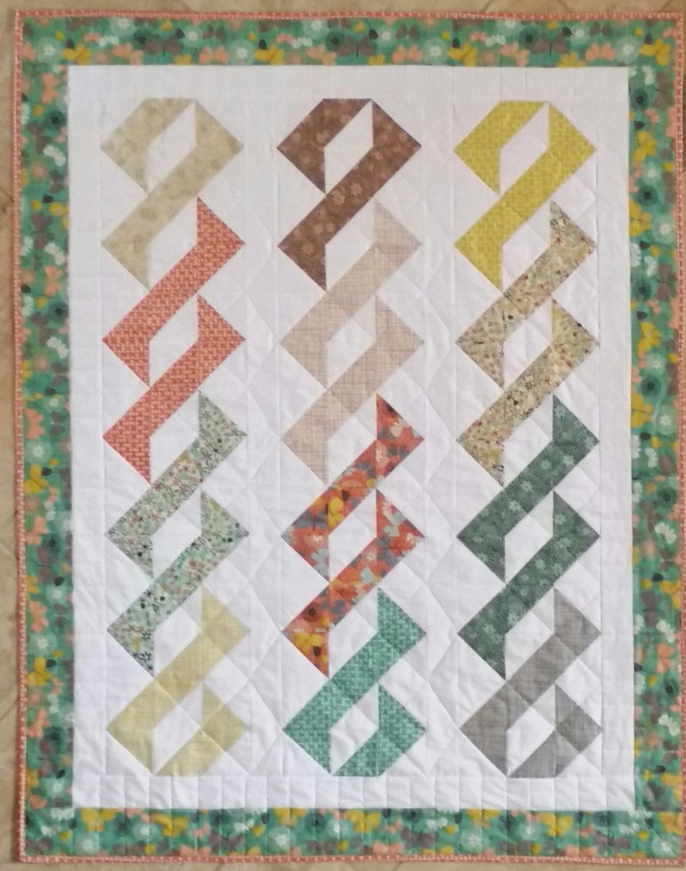
ASSEMBLING THE QUILT:
- Sewing the blocks in rows:
Col. 3 Fabric 9
Col. 2 Fabric 5
Col. 1 Fabric 1
- Sew the HSTs together in three (3) vertical rows or columns, grouped in order as pictured.
- Column #1 will have nine (9) Fabric #1, twelve (12) Fabric #2, twelve (12) Fabric #3 and nine (4) Fabric #10.
Col. 3 Fabric 10
Col. 2 Fabric 6
Col. 1 Fabric 2
- Column #2 will have nine (9) Fabric #5, twelve (12) Fabric #6, twelve (12) Fabric #7 and nine (9) Fabric #8.
- Column #3 will have nine (9) Fabric #9, twelve (12) Fabric #10, twelve (12) Fabric #11 and nine (9) Fabric #12.
Col. 3 Fabric 11
Col. 2 Fabric 7
Col. 1 Fabric 3

- Adding the vertical sashing between rows and the inner vertical borders.
Col. 2 Fabric 8
- Measure the length of the columns. If they are not all the same length, take an average measurement of the three columns.
Col. 3 Fabric 12
Col. 1 Fabric 4
- Cut two (2) 2 ½” x WOF strips to the measured length and sew the columns together.
- Cut two (2) additional 2 ½” x WOF strips to the measured length and add them to the vertical sides of the quilt.

- Adding the horizontal inner borders.
Measure across the top and bottom of the quilt. If these measurements are not equal, take an average measurement and cut two (2) 2 ½” WOF strips to the measured length and add them to the horizontal (top and bottom) sides of the quilt.

- Adding the outer borders.
- Once again, measure the vertical sides of the quilt and add your vertical outer borders, cut to the measured length.
- Do the same with the top and bottom of the quilt and add your horizontal outer borders, cut to the measured length.

- Quilt and bind as desired.

